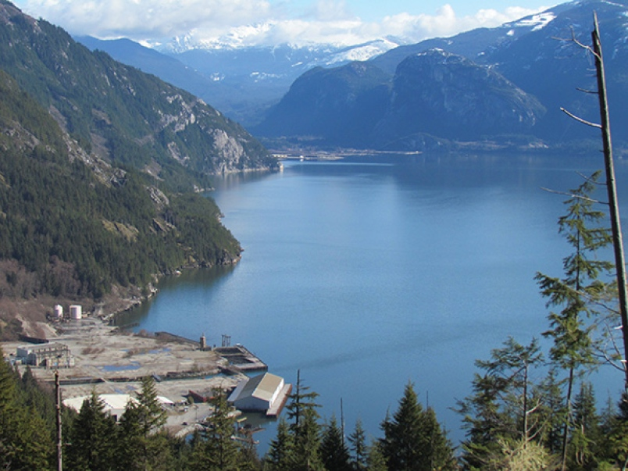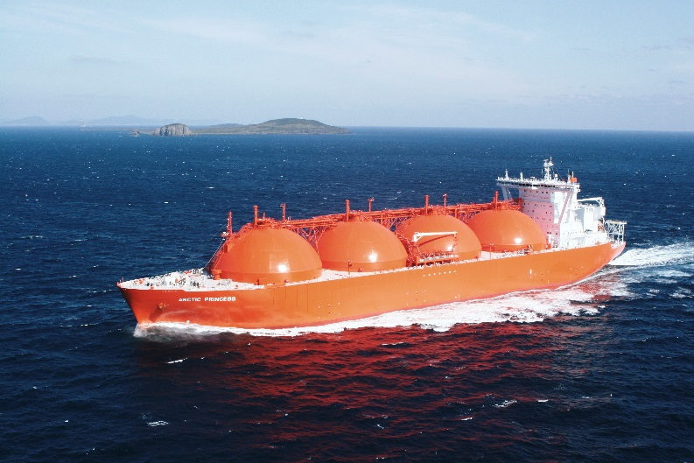[](http://www.google.ca/url?sa=i&rct=j&q=&esrc=s&source=images&cd=&cad=rja&uact=8&ved=0ahUKEwjg24GJ3NvRAhVW1mMKHarmAUQQjRwIBw&url=http://brightspark.com.pk/portfolio/federal-skilled-trades-program/&bvm=bv.144686652,d.cGc&psig=AFQjCNEiWAC2BIryr_-3EkIyN-Y3T8KHrg&ust=1485379491687933)**$**

**An LNG carrier is a tank ship designed for transporting liquefied natural gas (LNG). As the LNG market grows rapidly, the fleet of LNG carriers continues to experience tremendous growth. (Wikipedia)**

**The LNG project will create 650 construction jobs and 100 full time positions once the plant operates in 2020. (Global Mail)**

**$**

**$**

**$**

**$**

* 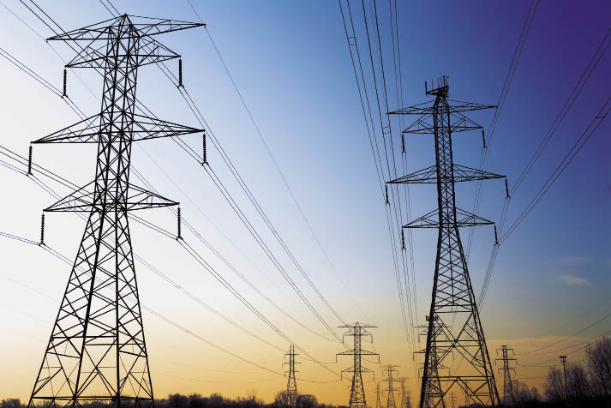**$**

**The LNG project in Squamish will be an investment of $1.6-billion**

**The LNG project will generate roughly $2 million in taxes for the district of Squamish and an average wage of between $70,000 and $75,000 (Business Vancouver)**

**$**

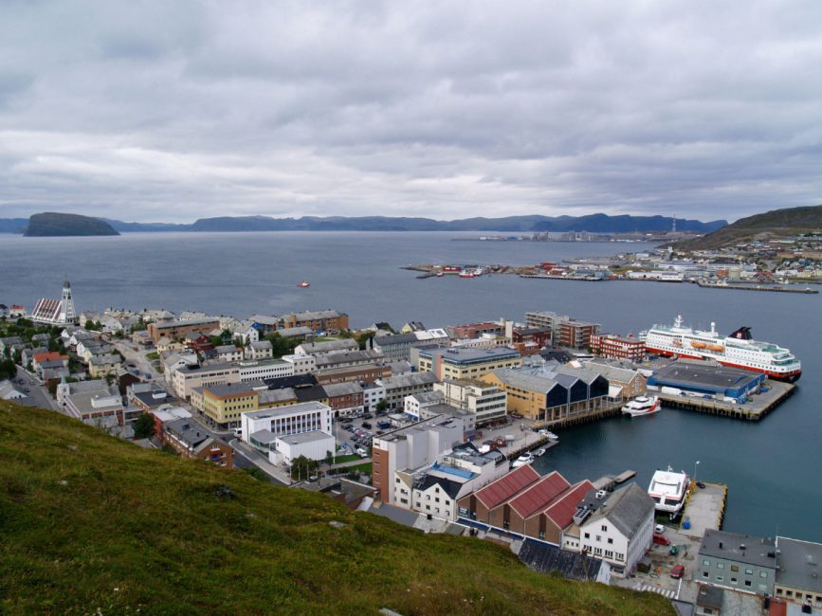[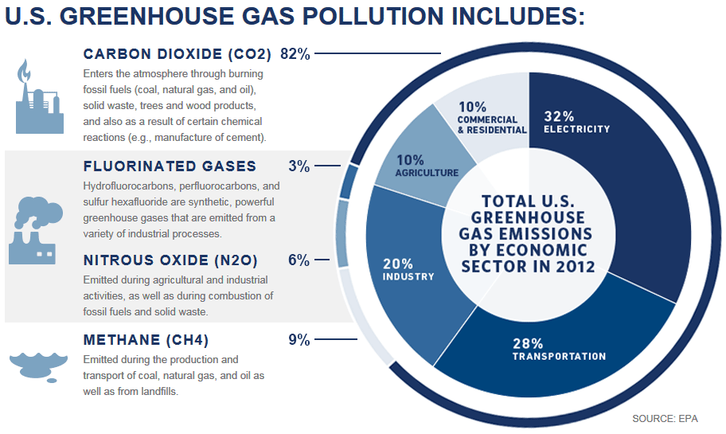](https://www.google.ca/url?sa=i&rct=j&q=&esrc=s&source=images&cd=&cad=rja&uact=8&ved=0ahUKEwiU__L55dvRAhVE5WMKHUD7DREQjRwIBw&url=https://cabaus.org/2014/06/02/calc-stands-with-epa-on-regulation/&psig=AFQjCNEY9xYPh8S6AQ07qz-52RJuPSCPWA&ust=1485382125434881)**$**

The LNG project will be using electricity to power the cooling process (Business Vancouver)

**$$**

**Natural gas transformed life in small Norwegian town**

**A liquefied natural gas plant brought good fortune — and smart growth — to the residents of Hammerfest, high above the Arctic Circle. Part of the 2015 Atkinson Series on public policy.**

**The Norwegian town of Hammerfest, once a fishing hub, has been reinvigorated by a liquefied natural gas plant on a nearby island. When the state-owned oil company Statoil set up shop, it agreed to fund the town's planning department for five years.  (Josephine Matyas file photo)**

GHGs have been reduced by 80% and that makes it one of the greenest LNG facilities (Byng Giraud Woodfibre VP)