Unit 2: Generating and Burning Hydrogen Gas Lab

OBSERVATIONS:
- Describe the chemical changes that occurred to the zinc metal.
- It started bubbling.

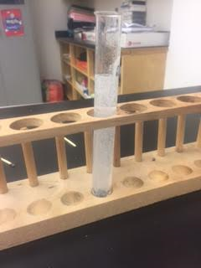
- How do you know that there was hydrogen gas in the large test tube? Explain.
- It started fogging up.
QUESTIONS / CONCLUSION:
- Calculate the mass difference in materials after the experiment. Ask the teacher to help you with this. If there isn’t much difference, explain why.

A: Empty test tube plus rack: 319.99

B: Full test tube plus rack: 381.89

C: Test tube plus rack:

B-A = 61.9 Mass of reactants
C-A = 19.6 Mass of products
- How can the difference in mass be explained? How might we “conserve” the mass? Explain.

Because there was a chemical reaction.

- We are going to explore this reaction type a bit later in the unit. For now, please write down the chemical formula (symbol and charge) for Zinc, HCl and Hydrogen Gas.

Zinc: ZN 2

HCL: Hydrochloric acid 0

Hydrogen gas: H 0

