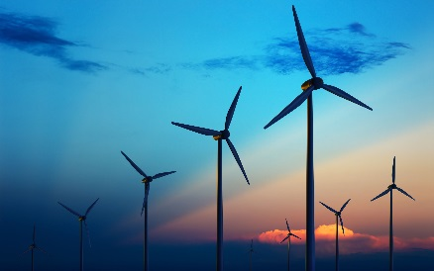
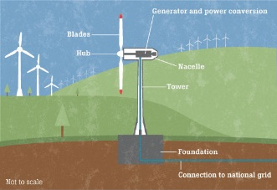
Wind as an energy source
Wind is a type of solar energy wind is a renewable energy source since ancient times people have harnessed the winds energy over 5,000 years ago the ancient Egyptians used the wind to sail ships down the Nile River.
Wind Farms
Wind is air in motion wind is caused by uneven heating on the earth’s surface by energy of the sun. The best situation to harness wind is where an area land and water meet. A wind farm is a grouping of dozens of wind turbines together in a big space to collect electricity.
Impacts:
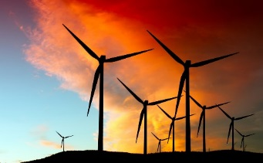
It has low impact on the environment however there is noise from the rotors and some birds and bats have been killed from the rotors.
Wind is a clean renewable energy source.
How is winds energy transported?
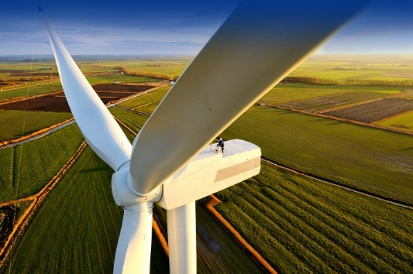
Wind can’t be stored and you don’t know when it will be windy but wind, charged batteries can be stored.
How is wind energy used?
It’s mostly used to generate electricity to power homes and businesses.
Pros and Cons:
A pro is wind is free because it’s part of mother nature.
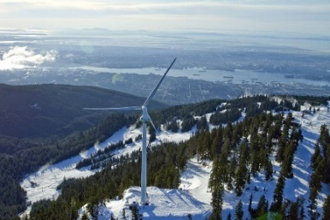
A con is wind turbines cost roughly 3,000 to 8,000 dollars
Global energy consumption
Global consumption of wind energy in the year 2015 was amounted to 432,883 MW.

Grouse mountain turbine local consumption
The Eye of the Wind can generate enough electricity in a year to service the needs of 400 homes.

https://youtu.be/qSWm_nprfqE

Sources:
Wind energy basics
windeis.anl.gov/guide/basics/
https://www.reference.com/science/wind-energy-used-4e56337b427a14a5
www.windustry.org/how_much_do_wind_turbines_cost
https://en.wikipedia.org/wiki/Wind_power_by_country
https://westcoastlivingcanada.com/2013/03/05/eye-of-the-wind/

